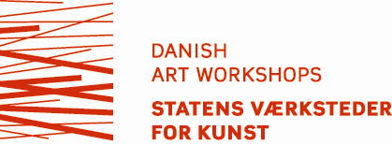

Please choose one of these four counsels to evaluate your application.
Visual arts
Design
Arts and crafts
Conservation
Application form

Date:

Name (artist name)

E-mail (only one e-mail address) | Telephone
Address

Zip Code, City | Country
Website (please note that your website does not fulfill the demand for image documentation)

Date of Birth

Project Title (we need it to register your project. You can easily change it later)

Application program (tick off)
Development
Production

Purpose of the Project

Type: tick off
Decoration
Exhibition
Prototype
Other

Do you have an exhibition? (yes/no)
If yes, where? (Write where the exhibition is supposed to take place. Please mark zip code, country, period)
Name of the exhibition space + period
Zip code
Country

The desired Period of Time at the Danish Art Workshops (max. 6 months, please state flexibility. You are obliged to postpone your application if your project concerns a period of time farther ahead than 1 year)

Number of days / weeks / months:

Preferred period:

Facilities needed while working at the Danish Art Workshops (studio and/or workshop facilities; please specify which workshops and which techniques/machines you intend to use)

Project Description (summery of max. 1500 characters) including your project’s connection to Denmark

Do you have any partners/cooperation on the project?

Name your reasons for carrying out the project at the Danish Art Workshops specifically

Any professional advice or guidance needed? (If so, in what field?)

Request for accommodation, if necessary (yes/no)

Have you been granted residency at the Danish Art Workshops before (if so, when?)

- Please remember to save your application on your own computer.
- Add your CV and image documentation following the application form.
- All the material must be e-mailed as one PDF file with a maximum of 5MB to ansoegning@svfk.dk

